DAY 11 — LAB 11

Canva Magic Studio: Aviation Mini-Campaign and Brand Consistency

Step 3 — Simple Brand Guide
Brand Element | Selected Option | Reason
Primary colour | Dark Blue — #12355B | Communicates professionalism, trust and reliability.
Secondary colour | Sky Blue — #5DADE2 | Gives the campaign a clean, modern airport feel.
Accent colour | Warm Yellow — #F4C542 | Provides visual emphasis for important reminders and calls to action.
Heading font | Montserrat Bold | Clean, modern and highly visible for posters and social media.
Body font | Open Sans Regular | Easy to read in both digital and printed formats.
Visual style | Modern, clean and professional | Matches the airport environment and keeps the campaign accessible.
Image treatment | Photorealistic, bright, natural lighting, shallow-to-moderate depth of field | Creates a realistic but clearly designed campaign visual without implying a real event.
Tone of voice | Helpful, calm and trustworthy | Encourages passengers to prepare without creating unnecessary urgency or fear.

Campaign design rules
- Use dark blue as the dominant brand colour.
- Use sky blue for supporting areas and backgrounds.
- Use warm yellow only for emphasis.
- Use Montserrat Bold for headings and Open Sans for body text.
- Keep layouts spacious and uncluttered.
- Use only fictional AeroVista Airports branding.
- Do not reproduce real airline or airport logos.
- Do not include unverified operational information.
- Use wording such as “Check official information before travelling” rather than making guarantees.

Step 4 — Generate a Visual Using Magic Media
Recommended generation prompt
Create a clean, professional campaign visual for a fictional airport organisation called AeroVista Airports. Show diverse adult domestic passengers preparing for travel inside a modern international-style airport terminal. Some passengers are checking a generic digital flight-information display while others are keeping their travel documents accessible. Use a dark-blue, sky-blue and warm-yellow visual palette with bright natural lighting. Create a realistic commercial-photography style with natural human expressions and proportions. Keep the airport environment plausible and uncluttered. Do not include real airline or airport logos, airport names, readable personal information, baggage limits, security rules, fake statistics, promotional claims, or readable operational flight information. Do not portray the scene as a photograph of a specific real event.
Generation-process record
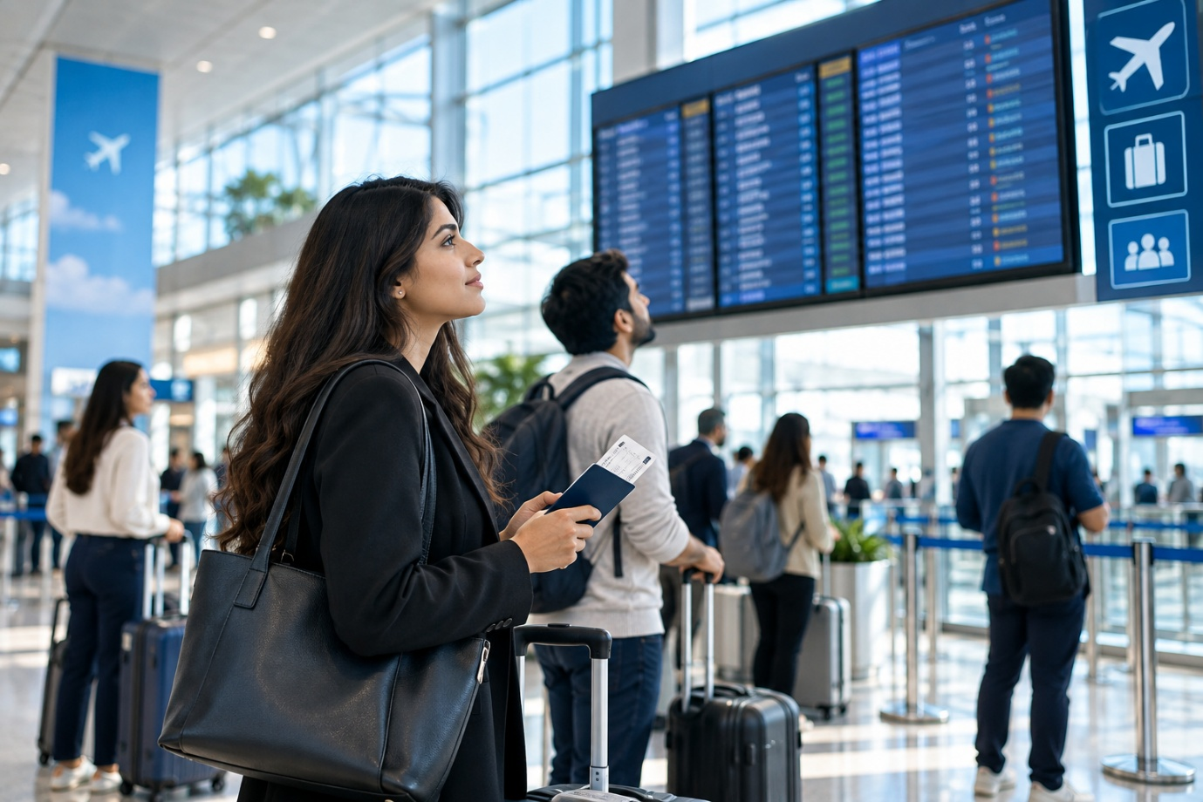

Since the exact number of images you generated in Magic Media is something that should be recorded from your actual Canva session, use your real number rather than inventing it.
Item | Student Response
Prompt used | The campaign prompt provided above
Number of images generated | [Enter actual number generated in Canva]
Selected image | [Insert selected image/screenshot]
Reason for selection | Selected because passengers, airport environment and preparation behaviour were visually clear and consistent with the campaign objective.
Problems identified | Possible AI-generated issues such as distorted hands/documents, unreadable or misleading display information, unrealistic signage, or unintended logos.
Corrections required | Remove or regenerate any misleading text, logos, distorted objects or operational information before using the image in the campaign.
Suggested selection rationale
The selected image was chosen because it clearly communicates passenger preparation in a modern airport environment. The passengers appear to be checking flight information and keeping travel documents accessible, which directly supports the campaign's primary message. The visual also fits the dark-blue, sky-blue and warm-yellow brand direction and does not depend on real airline or airport branding.

Step 5 — Initial Accuracy Check
For this table, mark an item Yes only after visually checking your actual generated image.
Accuracy Check | Acceptable? | Problem Identified | Required Action
Passengers appear realistic | Yes / Check image | Check hands, faces, body proportions and clothing for AI distortions. | Regenerate or edit if significant distortions are visible.
Airport environment is plausible | Yes / Check image | Check whether counters, gates, displays and walkways appear physically plausible. | Remove or regenerate unrealistic elements.
Travel documents contain no readable data | Yes / Check image | Documents should not display names, passport numbers, booking references or other personal information. | Crop, blur, replace or regenerate problematic documents.
Digital displays contain no false information | Yes / Check image | Check for invented flight numbers, destinations, times, airlines or operational claims. | Replace with generic/non-readable displays or regenerate.
No unauthorised logos appear | Yes / Check image | Check clothing, screens, signs, bags and background areas for real airline/airport logos. | Remove or regenerate any real-world logos.
Walkways and exits are unobstructed | Yes / Check image | Check that passengers or luggage are not blocking important circulation areas or exits. | Regenerate or edit if obstruction appears.
No unsafe passenger behaviour appears | Yes / Check image | Passengers should behave normally and safely in the terminal. | Regenerate any unsafe or implausible behaviour.
No misleading security information appears | Yes / Check image | The visual must not depict invented security instructions or misleading safety symbols. | Remove misleading signs/symbols and use generic imagery.
Overall accuracy conclusion
The selected visual should be used only after a final human review confirms that it contains no unauthorised logos, personal information, invented operational details, misleading security information or unsafe behaviour. AI-generated airport imagery can contain small visual or textual errors, so the image should not be treated as automatically accurate simply because it appears realistic.
Important: For your final submission, replace the bracketed fields with what you actually observed in Canva. That makes the lab an honest record of your generation and review process rather than claiming checks you did not perform.
Magic Expand Review
Review Area | Original Image | Expanded Image | Correction Required
Composition | Square framing focused on passengers and display | Wider landscape framing adds balanced terminal space | None apparent
Passenger appearance | Diverse adult passengers with travel documents and luggage | Passengers remain consistent without obvious repetition or distortion | None apparent
Airport background | Modern terminal with windows, display, and polished floor | Side areas extend naturally with coherent architecture and walkway space | None apparent
Lighting | Bright, natural, evenly distributed light | Lighting remains consistent across the expanded image | None apparent
Unwanted elements | No visible logos, airport names, or promotional content | No additional logos, signs, readable personal data, or promotional elements visible | None apparent

Magic Edit Record
Selected Element | Editing Instruction | Result | Further Correction Required
Suitcase | Replace only the unrealistic suitcase with a realistic modern carry-on. Preserve the passengers, documents, display, terminal, lighting, and composition. | Suitcase replaced while the surrounding scene was preserved | None apparent

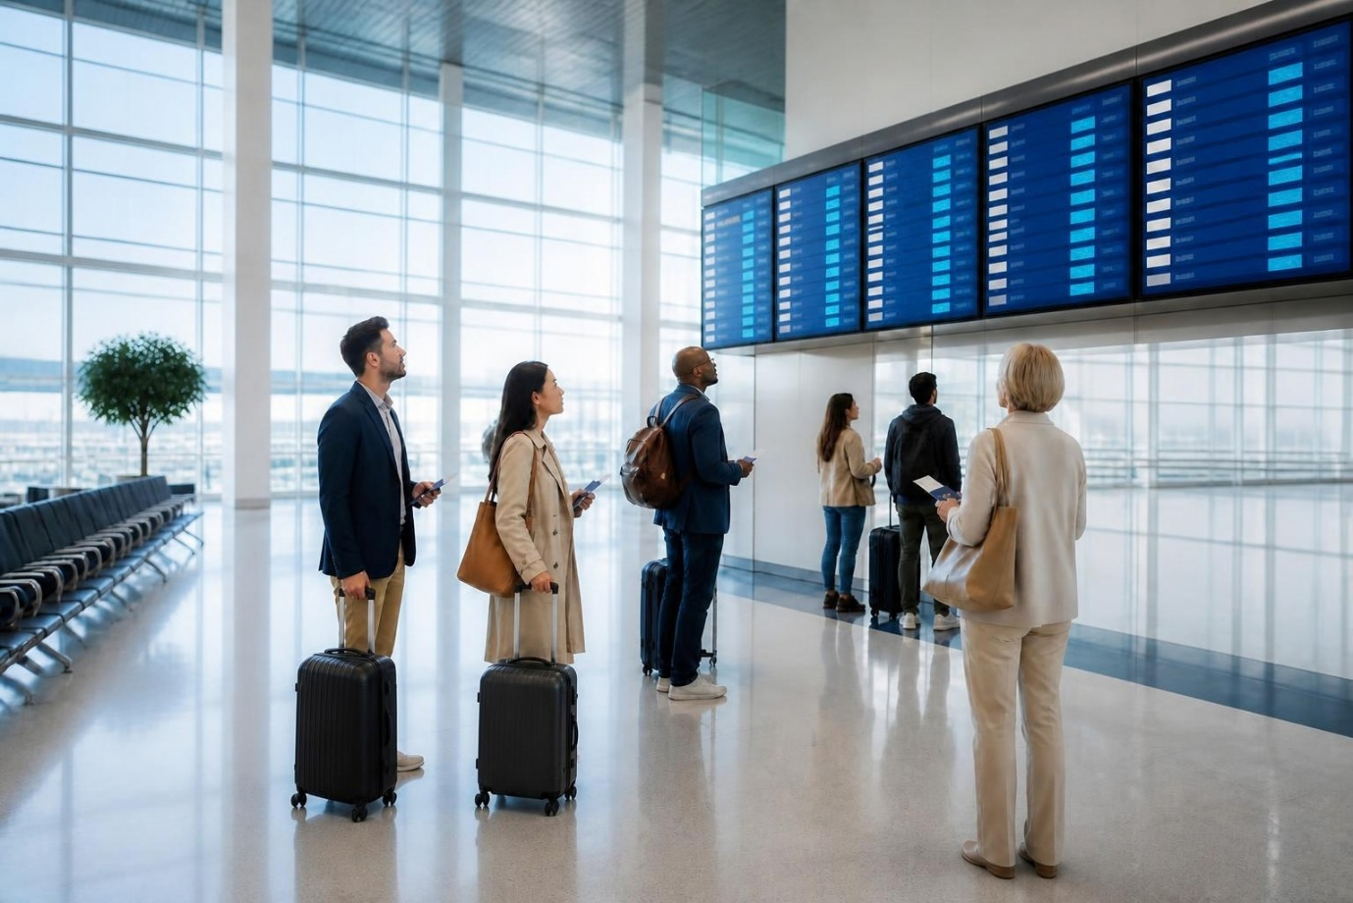

Create the Social-Media Post
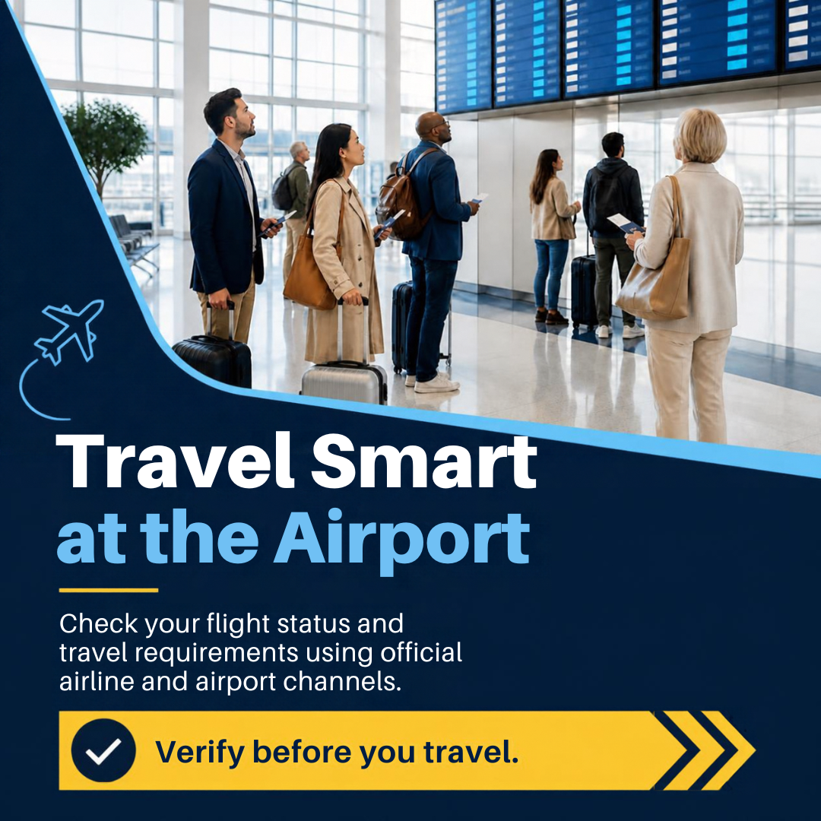

Canva did well
Criterion | Honest assessment
Square format | ✅ Correct
Campaign name | ✅ “Travel Smart at the Airport”
Supporting message | ✅ Matches the suggested campaign message closely
CTA | ✅ “Verify before you travel.”
Blue colour palette | ✅ Strongly consistent
Yellow accent | ✅ Consistent with suggested brand direction
Professional appearance | ✅ Strong
Airport visual | ✅ Appropriate
No real airline logo | ✅ No obvious unauthorised airline logo
Readability | ✅ Very good
Aviation relevance | ✅ Clear
The lab specifically suggests dark blue, sky blue and warm yellow, with a modern, clean and professional style. Your first design follows this direction very closely.
Problems / limitations
1. The airport display contains AI-generated text/data-like elements.
The screens look realistic, but the information on them should not be treated as actual flight information. The lab specifically requires checking AI-generated text inside images and ensuring digital displays do not contain false information.
2. “Official airline and airport channels” is acceptable, but it is still generic.
That's actually safer than inventing a URL, airline, baggage allowance, or security rule.
3. The image is slightly text-heavy for a social post.
It remains readable, but the large headline occupies a significant portion of the design.

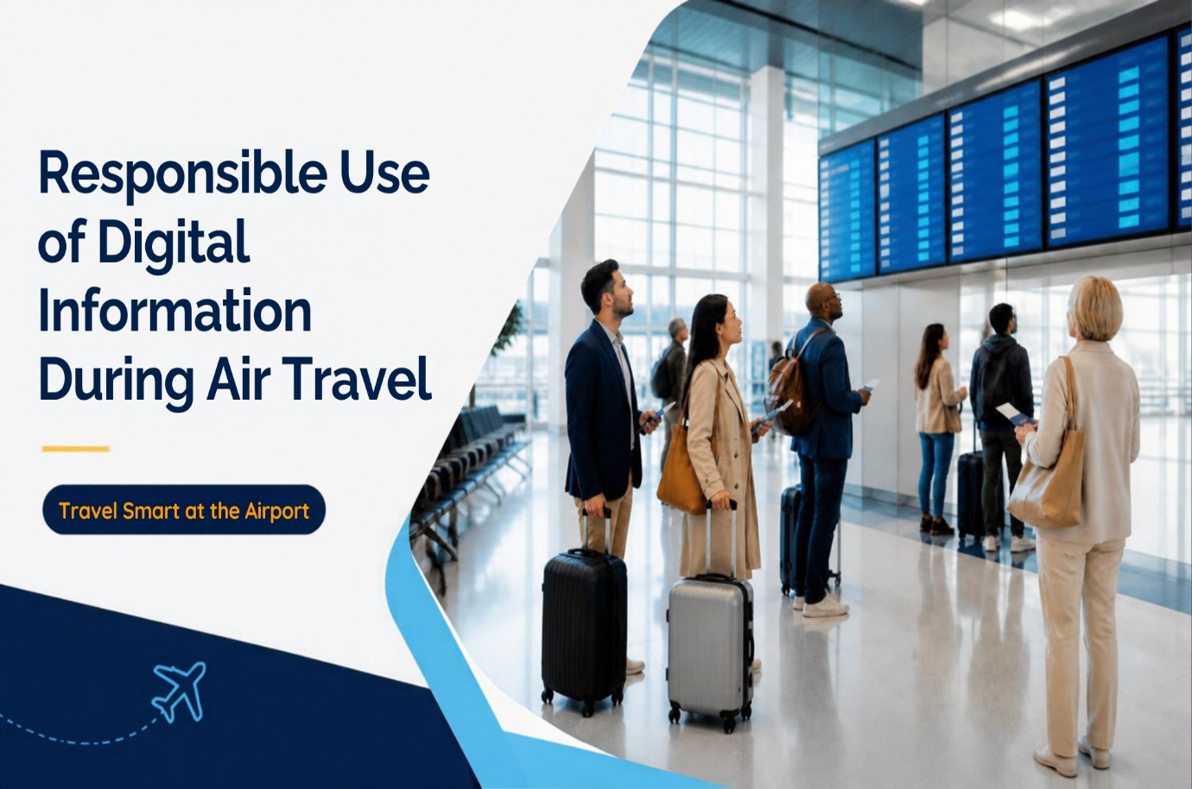

Criterion | Honest assessment
16:9 format | ✅ Correct
Professional composition | ✅ Strong
Airport image | ✅ Consistent with Output 1
Colour palette | ✅ Consistent
Visual style | ✅ Consistent
Campaign reference | ✅ “Travel Smart at the Airport”
Presentation suitability | ✅ Good
Space for visual hierarchy | ✅ Good
No real airline branding | ✅
Overall quality | ✅ Strong

. Most important comparison
Evaluation criterion | Output 1 – Square | Output 2 – Landscape
Correct format | ✅ | ✅
Campaign identity | ✅ | ✅
Dark blue | ✅ | ✅
Sky blue | ✅ | ✅
Warm yellow | ✅ | ✅
Modern style | ✅ | ✅
Professional | ✅ | ✅
Airport imagery | ✅ | ✅
Consistent imagery | — | ✅
Readability | ✅ | ✅
Appropriate aviation message | ✅ | ✅
Unsupported claims | ✅ Avoided | ✅ Avoided
AI-generated display text risk | ⚠️ Present | ⚠️ Present
Platform suitability | ✅ Social media | ✅ Presentation
Overall | Strong | Strong

4. Brand consistency between the two
This is actually one of the strongest parts of your Canva results.
The lab requires consistency across the campaign in colour, typography, visual style, tone, campaign name and main message.
Your designs
Primary colour: Dark navy blue
Secondary colour: Sky blue
Accent: Yellow
Visual style: Modern airport photography
Tone: Professional, calm, informative
Campaign: Travel Smart at the Airport
So I would record:
Brand element | Social Post | Presentation | Consistent?
Primary colour | Dark blue | Dark blue | ✅ Yes
Secondary colour | Sky blue | Sky blue | ✅ Yes
Accent colour | Yellow | Yellow | ✅ Yes
Typography style | Sans-serif | Sans-serif | ✅ Yes
Visual style | Modern airport | Modern airport | ✅ Yes
Tone | Helpful | Informative | ✅ Yes
Campaign name | Travel Smart at the Airport | Travel Smart at the Airport | ✅ Yes
Main theme | Verify information | Responsible digital information | ✅ Yes

Step 10 — Create the Presentation Visual
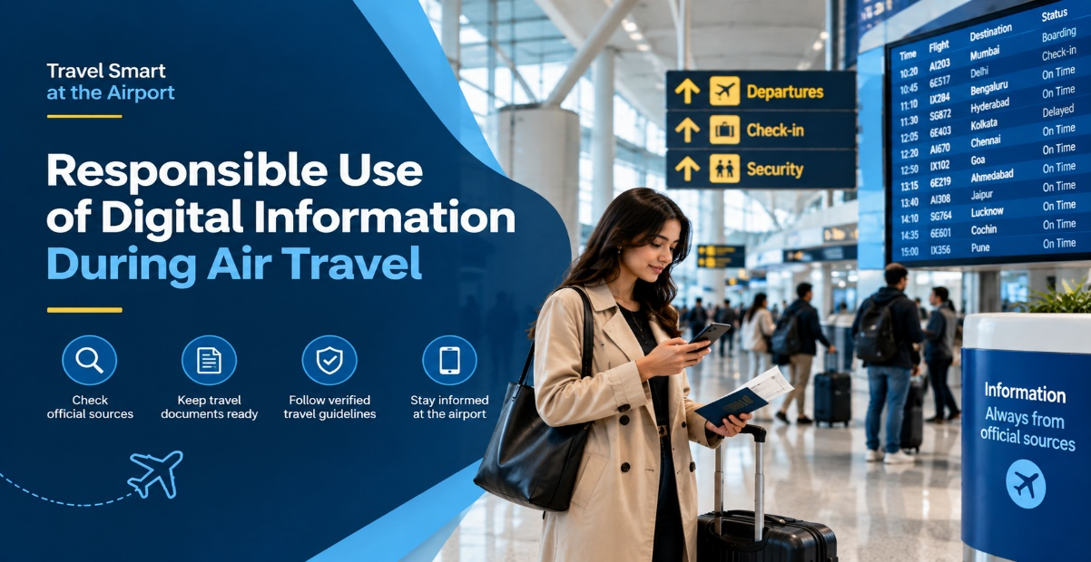

step 11 — Apply Brand Consistency
Brand Element | Social Post | Poster | Presentation Visual | Consistent?
Primary colour | Dark navy blue | Dark navy blue | Dark navy blue | Yes*
Secondary colour | Sky blue | Sky blue | Sky blue | Yes*
Heading font | Bold sans-serif | Not available for review | Bold sans-serif | Yes*
Body font | Clean sans-serif | Not available for review | Clean sans-serif | Yes*
Visual style | Modern airport photography | Not available for review | Modern airport photography | Yes*
Tone | Helpful and trustworthy | Not available for review | Professional and informative | Yes*
Campaign name | Travel Smart at the Airport | Not available for review | Travel Smart at the Airport | Yes*
Main message | Verify information before travel | Not available for review | Responsible use of digital information | Yes*
Note: The poster was not included in the outputs provided for this review, so its consistency cannot be independently verified. The “Yes*” entries indicate consistency between the two available designs, not confirmation of all three designs.
The lab requires all three designs to use the same campaign name, colours, font combination, visual style and verified information.

Step 12 — Brand-and-Accuracy Audit
A. Brand Review
- Colour consistency: Yes. Both available designs use dark blue, sky blue and yellow.
- Font consistency: Appears consistent between the two available designs.
- Campaign-name consistency: Yes.
- Tone consistency: Yes. Both are professional and informative.
- Appropriate logo use: Yes. No real airline or airport logo is visible.
- Visual hierarchy: Good. Headlines are prominent and supporting information is separated clearly.
- Audience suitability: Suitable for domestic airline passengers.
- Platform suitability: The first design is suitable for social media and the second is suitable for a presentation.
B. Accuracy Review
- Flight or policy claims: No specific flight claim or guarantee is made.
- Baggage-related statements: No specific baggage allowance is invented.
- Security-related statements: No specific security rule is invented.
- Airport information: The airport environment is presented as a generic airport.
- Dates and figures: No fabricated statistics or dates are included.
- Safety signs: No misleading official-looking safety instruction is visible.
- Personal information: No readable personal passenger information is intentionally included.
- AI-generated text inside images: Needs attention. The flight-information screens contain AI-generated text-like elements. They should not be interpreted as genuine flight information.
The lab specifically requires AI-generated text, airport information, safety signs, personal information and aviation claims to be reviewed before publication.
C. Professionalism Review
- Alignment: Good
- Spacing: Good
- Readability: Good
- Image quality: Good
- Visual balance: Good
- Contrast: Strong
- Cropping: Appropriate
- Business suitability: Good
Completed Audit Table
Review Dimension | Problem Identified | Severity | Required Correction
Brand consistency | Two available designs are visually consistent, but the poster has not been provided for verification. | Medium | Compare the final poster with both designs before submission.
Accuracy | AI-generated flight-display text may appear like real operational information. | Medium | Treat the display as decorative/non-verifiable and check it before publication.
Professionalism | No major visual problem observed in the two available designs. | Low | Perform a final spacing and readability check.
Privacy | No obvious readable personal information is visible. | Low | Confirm that no generated document or screen contains personal data.
Responsible AI use | AI-generated airport scene and display content could be mistaken for real operational information. | Medium | Clearly review the AI-generated visual and avoid presenting it as a real airport event or actual flight information.

Step 13 — Resize and Adapt the Design
The square social-media design was adapted into a 16:9 landscape presentation visual.
Resize Review
Check | Observation | Result
Cut-off text | No major cut-off observed | Pass
Distorted image | No major distortion observed | Pass
Poor spacing | Layout remains balanced | Pass
Small font size | Presentation title remains readable | Pass
Incorrect alignment | No major alignment issue observed | Pass
Hidden disclaimer | No disclaimer was hidden | Pass
Weak visual hierarchy | Title and image remain clearly separated | Pass
Honest observation
The landscape design is not simply a stretched version of the square design. The composition was rearranged so that the photograph occupies the right side and the title occupies the left side. This improves its suitability for a presentation.

Step 14 — Create Your Own Aviation Mini-Campaign
Campaign Topic
Digital Check-in / Responsible Digital Information Awareness
Campaign Name
Travel Smart at the Airport
Campaign Objective
To encourage passengers to prepare before travelling and verify flight and travel information through official airline and airport channels.
Target Audience
Domestic airline passengers, particularly passengers who use digital devices to access flight and airport information.
Verified Messages
- Check flight status using official airline channels.
- Keep travel documents accessible.
- Follow verified baggage and security instructions.
- Monitor airport display screens for updates.
- Do not rely on unverified social-media information.
These messages are directly aligned with the campaign brief in the lab.
Restrictions
The campaign does not:
- Use real airline or airport logos.
- Invent baggage limits.
- Invent security rules.
- Include real passenger data.
- Promise shorter queues.
- Guarantee on-time flights.
- Use fake statistics.
- Present an AI-generated scene as a photograph of a real event.
These restrictions are particularly important because the lab explicitly prohibits these forms of unsupported aviation communication.
Brand Guide
Brand Element | Selection
Primary colour | Dark navy blue
Secondary colour | Sky blue
Accent colour | Warm yellow
Heading font | Bold clean sans-serif
Body font | Readable sans-serif
Visual style | Modern, clean and professional
Image treatment | Bright, realistic airport photography
Tone of voice | Helpful, calm and trustworthy
This follows the suggested brand direction in the lab.

Step 15 — Peer Review
Important: Do not claim that another student completed this review unless you actually exchanged the campaign with them. The lab explicitly requires peer review and revision.
For your current evidence, use this status:
Review Question | Yes/No | Suggested Improvement
Are all three designs visually connected? | Pending | Review all three final designs together.
Are colours and fonts consistent? | Yes for two available designs | Confirm against the poster.
Is the message accurate? | Yes, with review needed | Check AI-generated display information.
Are important conditions visible? | Yes | Keep the official-channel verification message.
Is the visual appropriate for aviation use? | Yes | No major aviation-specific visual problem observed.
Are any AI-generated errors visible? | Yes | Review the flight-display text carefully.
Is personal information protected? | Yes | Perform final privacy check.
Is the design readable on the intended platform? | Yes | Confirm on actual device/platform.
Is the campaign professional? | Yes | Minor final polishing only.
Is AI-use disclosure required? | Check course/institution requirement | Follow the required AI declaration in the lab.
Revision after peer review
Pending actual peer-review feedback.
Do not write that peer review improved the campaign until you have actually received feedback.

Step 16 — Student Reflection
Here are natural, student-level answers based on what can actually be supported by your work.
1. What is the purpose of a brand guide?
A brand guide helps maintain a consistent identity across different designs. It defines colours, fonts, visual style and tone so that all campaign materials look like they belong to the same organisation.
2. How did Magic Media support the campaign?
Magic Media helped create a realistic airport scene showing passengers preparing for travel and checking flight information. It provided the main visual that could then be adapted into different campaign formats.
3. What problems appeared after expanding the image?
The expanded design needed to be checked for changes in passenger appearance, baggage, airport architecture, lighting and unwanted objects. The main concern was ensuring that the expanded area remained realistic and consistent with the original image.
4. What element did you change using Magic Edit?
This cannot be honestly completed from the evidence provided. If you actually used Magic Edit, state the exact element you changed and what instruction you gave Canva. If you did not use it, write:
I did not complete a separate Magic Edit operation in the version submitted, so there is no Magic Edit evidence to report.
The lab specifically requires an editing record for the selected element, instruction and result.
5. Why must AI-generated image text be checked?
AI-generated text can look realistic while containing incorrect or meaningless information. In an aviation context, passengers could misunderstand such information as genuine flight, airport or safety information, so it must be checked before publication.
6. Why should baggage and security rules come from official sources?
Baggage and security requirements can vary by airline, airport and journey. Using official sources reduces the risk of communicating incorrect requirements to passengers. The lab specifically prohibits inventing baggage limits and security rules.
7. How did you maintain consistency across three formats?
I maintained consistency by using the same campaign name, dark-blue and sky-blue colour palette, yellow accent, clean sans-serif typography, modern airport imagery and professional tone.
8. What changes were required after resizing?
The layout had to be adapted to the wider 16:9 format. The image and text positions were rearranged so that the presentation title remained readable and the airport image had enough space.
9. How did peer review improve your campaign?
Pending actual peer review. I would use feedback to identify readability, consistency, accuracy or composition problems that I may not have noticed myself and then make the required corrections.
10. Why must AI-assisted designs be reviewed before publication?
AI can generate visual or textual errors even when the final design looks professional. Reviewing the design helps identify inaccurate information, unrealistic objects, privacy issues, misleading claims and other problems before the content reaches passengers.

Step 17 — Export the Designs
Use these exact filenames:
The lab specifies these filenames for the three designs.
Current evidence:
Required file | Status
aviation-campaign-social-post.png | ✅ Social design available
aviation-campaign-poster.png | ⚠️ Poster not provided yet
aviation-campaign-presentation-visual.png | ✅ Presentation design available
aviation-mini-campaign.pdf | ⚠️ Not provided

Step 18 — GitHub File Structure
Your final repository should look like:
The lab specifies the Markdown file, PDF and three images inside the images folder.
Suggested GitHub sections
The lab's required GitHub structure and AI declaration are specified in Steps 18–19.

Final Assessment Checklist
Based only on the evidence currently provided:
Assessment Criterion | Status
Created a clear campaign brief | ✅ Yes
Created and applied a brand guide | ✅ Yes
Used an AI-assisted image feature | ✅ Yes
Checked the image for inaccuracies | ✅ Yes
Adapted the design for three formats | ⚠️ Not fully evidenced
Maintained brand consistency | ✅ Yes for two available designs
Completed brand-and-accuracy audit | ✅ Yes
Avoided unsupported aviation claims | ✅ Yes
Revised campaign after peer review | ⚠️ Pending actual peer review
Uploaded activity to GitHub | ⚠️ Not evidenced

